|  |  |
| --- | --- |
|  |  |
| *Optical Mark Recognition* |  |
|  |  |
|  | April 13, 2021Ahmed Nabil LotfyAhmed Ahmed ElrewaidyEslam Khalid ElfauomyAkram Hesham RagabBasma Mohamed Ahmed |

### TABLE OF CONTENT:

* ***Introduction*** 
  + *Computer Vision*
  + *Optical Mark Recognition*
* ***Project Overview*** 
  + *OMR in MCQ grading*
* ***Project Flow***
  + *RGB image to Gray*
  + *Gray to Blur*
  + *Edge Detection*
  + *Contours Detection*
  + *Circle Detection*
  + *Count objects*
* ***Conclusion***

### INTRODUCTION:

Computer vision is a ﬁeld that includes methods for capturing, pre-processing, analyzing, and understanding images. A theme in the development of this ﬁeld has been to duplicate the abilities of human vision by electronically perceiving and understanding an image. To solve optical mark recognition problems, we need to use some functionalities powered by computer vision.

But why bother? Normally counting objects with a naked human eye looks easy, but the main thing is it will take time to count all the objects in a speciﬁed area. The human errors in counting objects will decrease the efﬁciency of the work and it is also very tiring for the person performing the task. There can also be some overlapping objects in the scene which make the task challenging to accomplish.

### Project overview:

optical mark recognition is the process of detecting marks in images. It’s usually used in survey and tests. In our project, we’ve used it to auto grade a bubble sheet.

An optical answer sheet or bubble sheet is a special type of form used in multiple choice question examinations. Optical mark recognition is used to detect these answers.

Optical answer sheets usually have a set of blank ovals or boxes that correspond to each question, often on separate sheets of paper. Bar codes may mark the sheet for automatic processing, and each series of ovals filled will return a certain value when read. In this way students' answers can be digitally recorded, or identity given.

### Project Flow:

1. RGB image to Gray

Firstly, the RGB image is retrieved figure. 1, in our case we will work on 200 questions optical answer sheet. we convert it into gray image “gray image is simply one in which colors are shades of gray” figure. 2

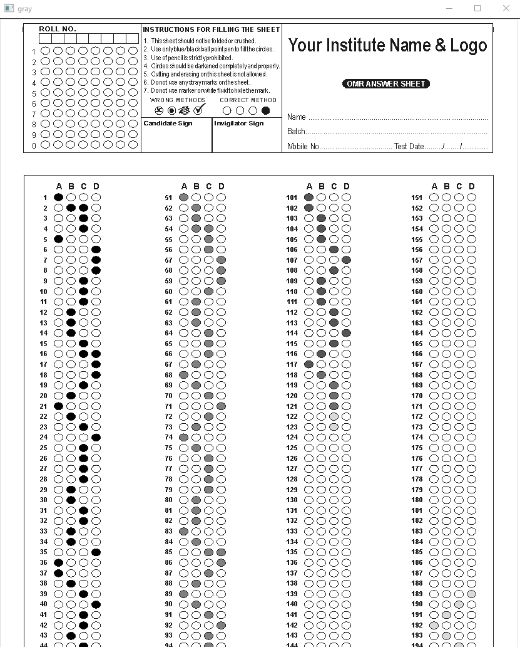zgray image is better than other sort of color images because less information needs to be provided to each pixel hence faster computation.

Figure.

Figure.

1. Gray to Blur:

Blurring the image to remove outliers and noise.

We will use of Gaussian Blur to do that before moving to Edge Detection.

1. Edge Detection:

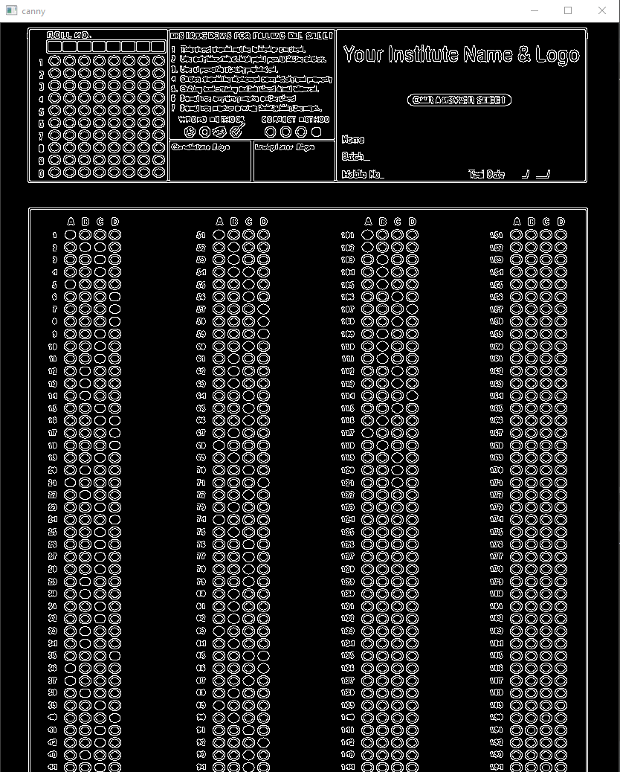 The aim of performing edge detection in general is to signiﬁcantly reduce the amount of data in an image, which will be used in the further processing. This step increases the computation speed of the approach while preserving the structural properties of the image. Several algorithms exist for edge detection, such as Prewitt, Sobel, Roberts, and Canny figure. 3 are available out of which the performance of canny is far better. it has become one of the standard edge detection methods and is used in our work.

Figure

1. Contours Detection

Contour detection is a technique to ﬁnd out the boundaries of pixels with sharp intensity changes. Contours consist of a set of points connected to each other, most likely to be located on the outlines of objects. Contours Detection takes the output of the canny edge detector do its calculations to get information that can be used to extract and draw needed contours.

Since we are only interested in the oval answers, we will draw contours on the bottom table only. Figure. 4

Figure. 5

1. Circle Detection:

Canny edge detector happened to be so good at detecting edges. So, we had to find a way to detect only the circles we are interested in. this can only happen by putting some threshold in the shapes of interest and then feed it to array to test it with answers.

1. Count Objects:

We can count those detected circles to get our answers. For each circle we can count the number of zero pixels and one pixels to detect if it’s bubbled or not.

### CONCLUSION:

In order to build an OMR system. We needed to choose between circle detection algorithm and edge detection algorithm. We favored edge detection algorithms because circle detection was intolerant with not perfect circles and also didn’t work well with many circles in our bubble sheet.